|  |
| --- |
|  |

|  |
| --- |
| **PHASE I: Investigation and Analysis** |
|  |
|  |
| A project about a meta-reviews program that will unite the reviews for a collection of mobile Apps across different mobile platforms.  **Educator: Dl** |
| **12We** |
| **Steven Groenewald** |
|  |

Table of Contents

1. Problem Statement 2

2. Investigation 2

Current Systems and Processes 2

Demographic 2

Key Areas of problem 3

Security 3

Organisation 3

Responsibility and Bias 3

Data Integrity 3

Current Systems and Processes 3

3. Requirements For Processes in the program 4

Sign Up 5

Log In 5

Removing Users 6

Upgrading Users 6

Adding Apps to Database 7

Rating and Reviewing 7

Removing/changing apps 8

Queries 8

Saving 8

4. Possible Solution 9

5. General 9

Scope and Nature of Problem 9

Needs of users And information from users 9

Limits / Future Plans 9

Bibliography 10

# Problem Statement

Phone app users are finding companies more and more unscrupulous as they promote their own apps over those of other companies. Money often changes hands and voting is unregulated – causing mistrust by users. Thus we find the need for an all-encompassing programme that is democratic, unbiased and supported by the users – not developers.

My programme will allow users to review and rate apps across different OS and genres to allow then the best selection while giving them a completely unbiased and honest review system. Administrators will be allowed to remove troublesome/fake users. It will be in English as the Lingua Franca for now.

Phone apps across app stores have become similar to package managers in the Linux OS family (Haas), this interest in package managers and smartphones has led me to see the conflict of ideals and logic between to the two ideas – commercial app store and trustworthy package manager.

# Investigation

## Current Systems and Processes

My programme will replace the current system for helping users decide which apps to buy or download. There are many reasons for the current system being replaced:

* Developers don’t always have a fair chance as their reviews are often biased.
* Users need a fair and unbiased system to speak their mind without big money influencing the votes. Many apps systems are only for a certain OS yet many customers use multiple OSs and thus can choose between more apps than currently reviewed in one system.
* Voters unregulated – pollutes App World (blackberry) and iOS (Apple) with false ratings/plain and unscrupulous lies.

## Demographic

The users of my program will range from the young first-time smartphone users to those in their 30s and 40s who are looking for an informative and all-encompassing app recommendation system. So basically, the demographic is anyone who’s interested in new apps for their phones (Alex, 2012) and tablets. The majority are literate, fairly wealthy and educated.

Apps have many different genres (Health & Fitness Finance etc.) so it’s difficult to pinpoint who exactly will be interested in this new programme.

## Key Areas of problem

I need to make sure the program is unbiased and uses queries to present useful and new information to the users.

### Security

This program will limit accounts by having them enter their phone number and email (for tablets) this limits them to two accounts (which severely limits people who wish to lie or falsify reviews).

### Organisation

To make useful reports and queries the apps must be divided by genre (Health and Fitness, Social Networking, etc.) as well as a list of compatible devices and OSs. This prevents confusion and makes it easier to provide quality information to consumers.

### Responsibility and Bias

Users who are deemed false and or biased (always reviewing apps by a certain developer positively – suspicious behaviour) can be banned by Administrators. New Administrators will be “upgraded” users who have proven that have loyalty to the fair system.

### Data Integrity

For this system to maintain plausibility and usability it must be accurate and include the opinions of ALL users of the program. To achieve this, I will be utilising a server/client computer distribution so that many clients can keep the server’s database growing and valuable. This will eventually become the backbone of the programme’s wealth – and data mining may provide valuable information to investors (for app companies) to help fuel the competitive app ecosystem on mobile devices.

## Current Systems and Processes

Currently people are forced to rely on the app stores which have monetary incentive to rate their own apps higher than those of competitors. The app rating/review system also allows anyone who owns certain device to rate apps – this can lead to unregulated and fake voting, with developers purchasing good ratings to boost sales.

# Requirements For Processes in the program

These requirements are normal for online reviews:

This is the norm which my program will be following in its future design.

Yelp: Allowing you to review local businesses and find great local stores.

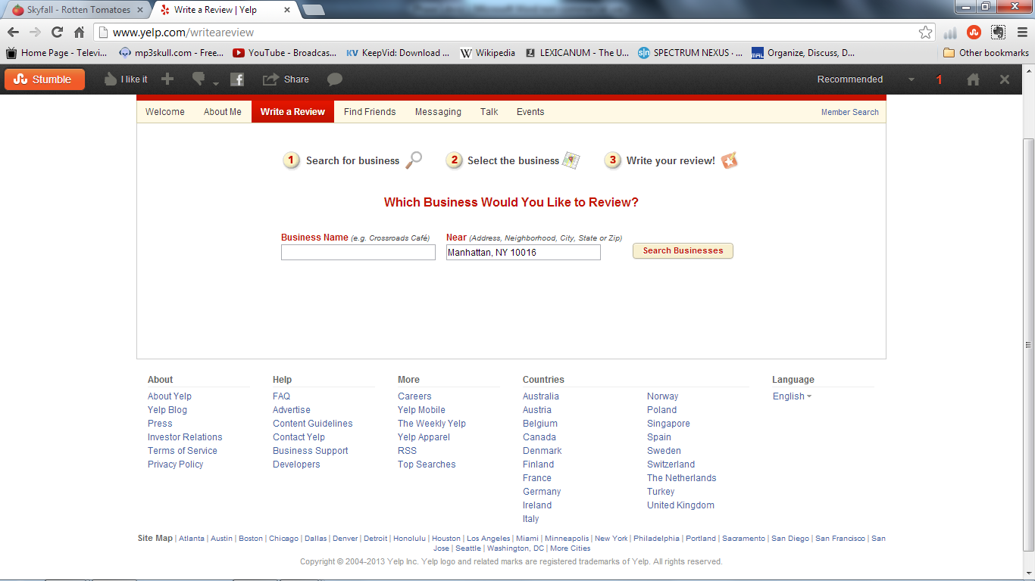

Rotten Tomatoes (A movie meta-review site that aims to make sure you never see another bad –and expensive- movie again) 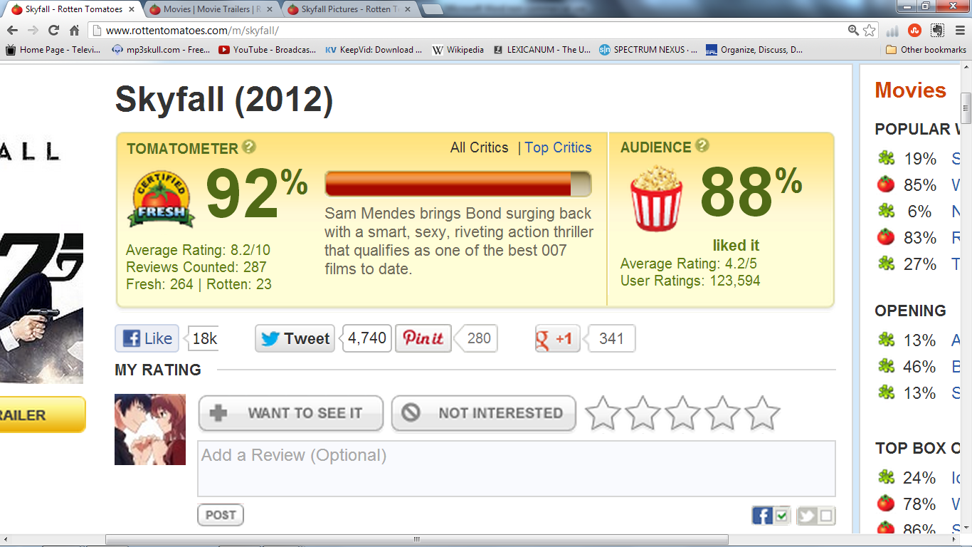

### Sign Up

#### Input

Users:

* Name
* Surname
* Age(for perspective only – do not have to be 18 to sign up) – in years
* Email address
* Country

#### Processing

* Email is checked to be valid (one @ only) as well as checked to see if the email is registered already.
* The name and surname are checked for numbers and symbols.
* Age is checked for letters.

#### Output

* The user gets a message that they have been registered and the login screen opens if everything was correct. A generated password and username is sent to the user’s email address, which is used for future emails of importance. They use these details to login.
* Otherwise, they are informed if the name or surname or age is incorrect.
* If the email address is already in use, they will be allowed to retry the signup infinitely.

### Log In

#### Input

The user enters their

* username
* password

#### Processing

The password and username are checked to match.

#### Output

They are shown a welcome message and the main program screen or pane will open.

### Removing Users

#### Input

If an administrator wishes to delete a user, they are requested to enter:

* their username
* Their own password (this prevents someone misusing an admin’s station while he is away from his keyboard).

#### Processing

The password is checked to be correct.

#### Output

* The administrator receives a message informing him of the deletion.
* Or they are told that the password is incorrect.

### Upgrading Users

#### Input

. This is checked when an

* Admin clicks a button - Users will be upgraded by administrators after 5 recommendations (one per an administrator per a user).

#### Processing

* The update query runs and instates new administrators.

#### Output

* New users will be informed upon login.
* A message confirms that eligible users have been upgraded.

### Adding Apps to Database

#### Input

An administrator enters:

* Their own password.
* The name of the App
* The available operating platforms
* The price
* Whether or not the app is available on subscription.
* The phone models which can use the app.
* The genre of App(from a predetermined list)

#### Processing

* Password checked to belong to admin.
* App details are checked to avoid duplicate entries of the same app.
* There is also a format check to make sure currency is correct.

#### Output

* When an App already in use is entered a message is shown explaining this.
* Otherwise, a message states that the app has been added.

### Rating and Reviewing

#### Input

The users will enter:

* an app for review;
* overall rating(dropdown choice)
* a comment explaining their rating well, that is not biased or unreasonable

#### Processing

* The review is saved/added
* The fields are checked to contain info.
* The average rating is recalculated.

#### Output

* The user is notified that the review has been kept

### Removing/changing apps

#### Input

The administrator will remove or edit the app by entering the name of the app, as well being given the option to change the available platforms and price.

#### Processing

* The app is validated (i.e. in the database); if it doesn’t exist a message states this.
* If the administrator wishes to change information, the format must be checked (currency).

#### Output

A message will state that the app has been changed or removed as necessary.

### Queries

#### Input

The user will input app:

* Price range
* OS
* Genre
* Minimum rating

#### Processing

* The select query is run on the app table.
* The query is checked for results.

#### Output

* This list is returned to the user.
* If there are no results a message will explain this.

### Saving

#### Input

* The user will be allowed to save their queries for reuse or to send to friends.
* They click a button and choose a location to save this into.

#### Processing

* The select query is run on the app table.
* The query is checked to contain more than one record.
* This information is saved to a text file, with a name of their choosing, at the specified location.

#### Output

* This list is returned to the user
* If there are less than 2 results a message will explain this.
* The text document can be found in the correct place.

# Possible Solution

My client/server application linking to a backend database will solve these problems.

# General

## Scope and Nature of Problem

This problem will be solved with a server and a client solution, with later expansion of a mobile app, to reach the target audience directly. Client programs shall run on user’s computers

This solves the serious inconvenience of slowly downloading an app (losing money and battery life – a serious concern for smartphone users) only to find the app to be useless.

## Needs of users And information from users

The user’s needs have been described as needing a nice GUI programme, at a later date we may expand into mobile apps – if funding is there (perhaps KickStarter). The user’s information (myself and other friends have been references) indicates they need to be able to compare apps across platforms (Tablets/Phones) as well as Oss (iOS etc.). I have also discovered that they would like them to be listed by overall rating and not by amount of votes in anyway (allows for exposure of smaller releases).

## Limits / Future Plans

This project will require a person to use the program off a desktop computer which has the client program – this will connect to the server online (this requires an internet connection). This limits who can use it and the effectiveness of the program.

In the future, I would like to run it through a web page as well as an app release on all OSs and sync it to a server. This improves the integrity and importance of the information that is generated, while allowing us to directly reach the target market on their devices.

Eventually the program will be more widespread and apps will encourage users to review them (Zhu, 2009). This will be done with a QR code on posters of their app that links to a review form (on Google docs or our website). This will be in addition to the users being prompted to review the app by the app itself.

If any app ever gives rewards for users doing reviews, we will remove their app from our system and pronounce them to be “rogues”.

# Bibliography

Alex, A. (2012, December). *Smartphone Usage Statistics*. Retrieved 02 16, 2013, from www.ansonalex.com: www.ansonalex.com/smartphone-usage-statistics-2012-infographic/

Haas, J. (n.d.). *Linux Packages*. Retrieved January 29, 2013, from about.com: http://linux.about.com/od/linuxdocumentation/a/docpackages.htm

Thompson Gale. (2006). *Heinrich Lenz*. Retrieved from Book Rags: http://www.bookrags.com/biography/heinrich-lenz-wop/

Various. (n.d.). *Voting Rights Act*. Retrieved February 08, 2013, from Wikipedia: http://en.wikipedia.org/wiki/Voting_Rights_Act

Zhu, F. (2009, April 21). *Impact of Online Consumer Reviews on Sales: The Moderating Role of Product and Consumer*. Retrieved 01 29, 2013, from Mike Zhang Blog: http://blog.mikezhang.com/files/gamereviews.pdf